Report of Homework 3 in Computer Software Application



Teacher’s Name: İlyas Çankaya

Student’s Name: Hikmet Ünüvar

Student’s Number: 19050211059

The Matlab Code:

% Collecting input data through a compact input dialog setup

prompt = {'Enter resistance R1:', 'Enter resistance R2:', 'Enter resistance R3:', 'Enter resistance R4:', 'Enter resistance R5:', 'Enter supply voltage V:'};

dims = [1 35];

definput = {'20','20','20','20','20','10'};

inputs = inputdlg(prompt, 'Input for Circuit Calculation', dims, definput);

% Assigning inputs and converting to double

R1 = str2double(inputs{1});

R2 = str2double(inputs{2});

R3 = str2double(inputs{3});

R4 = str2double(inputs{4});

R5 = str2double(inputs{5});

V = str2double(inputs{6});

% Calculations Voltages and Powers

R = [R1, R2, R3, R4, R5];

totalR = sum(R);

I = V / totalR;

Voltages = I .\* R;

Powers = Voltages .\* I;

% Preparing data for the ui table

data = [R', Voltages', Powers'];

% Creating and configuring the figure and table with some qualities

f = figure('Position', [100 100 420 250]);

t = uitable('Parent', f, 'Data', data, ...

            'ColumnName', {'Resistance', 'Voltage', 'Power'}, ...

            'RowName', {'R1', 'R2', 'R3', 'R4', 'R5'}, ...

            'Position', [20 20 380 200], ...

            'BackgroundColor', [0.7 0.9 0.9; 1 1 1]);

% Auto-adjust column widths and center the figure window

t.ColumnWidth = {'auto', 'auto', 'auto'};

movegui(f, 'center');

Outputs:

In “inputdlg” command

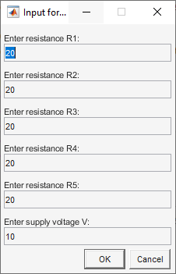

In “uitable” command:

metin, ekran görüntüsü, ekran, görüntüleme, yazılım içeren bir resim

Açıklama otomatik olarak oluşturuldu

Flowchart of the MATLAB Code:

metin, ekran görüntüsü, çizgi, diyagram içeren bir resim

Açıklama otomatik olarak oluşturuldu